

**Student Placement System**

**eProject**

**Documentation**

**Introduction To Our Team**

1. Mr. Faiq Yaseen 1256162
2. Mr. Muhammad Sufiyan 1256023
3. Daniyal Haider 1061919
4. Syed Faras Al Makkavi

**Further Details**

Faculty **:** **Miss Zainab**

Batch Co-ordinator **:**

Batch **:** **PR201912C**

Curriculum **:** **ACCP Prime**

Semester **:** **HDSE2**

**Table of content:**

* Acknowledgment.......................................................................................................03
* Abstract…………………………………………………………………………………………………………03
* Declaration…………………………………………………………………………………………………………03
* Certification………………………………………………………………………………………………………………….05
* INTRODUCTION…………………………………………………………………………………. 06
* Problem Statement………………………………………………………………………………… 09
* Deliverables…………………………………………………….09
* Need of Project………………………………………………………………………………………09

PROJECT MAKING & BACKGROUNDS………………………………………………. 09

Project Duration………………………………………………………………………………………. 09

SOFTWARE & HARDWARE REQUIREMENTS……………………………………09

* Hardware Requirements……………………………………………………………………………. 09
* Software Requirements……………………………………………………………………………… 09

WORKFLOW SUBMISSION CHECKLIST……………………………………………10

* Workflow Submission Checklist…………………………………………………………………….. 10
* Tasksheet……………………………………..11
* ER Design……………………………………..13
* Screenshots…………………………………………………………………………………………………13
* Coding……………………………………………………………………………………………………19

CONCLUSION………………………………………………………………………………

* Remarks…………………………………………………………………………………………………………37
* Application……………………………………………………………………………………………………. 37
* Future Enhancement……………………………………………………………………………………… 37

**Introduction**

The thirst for learning, upgrading technical skills and applying the concepts in real life environment at a fast pace is what the industry demands from IT professionals today. However busy work schedules, far-flung locations, unavailability of convenient time-slots pose as major barriers when it comes to applying the concepts into realism. And hence the need to look out for alternative means of implementation in the form of laddered approach.

The above truly pose as constraints especially for our students too! With their busy schedules, it is indeed difficult for our students to keep up with the genuine and constant need for integrated application which can be seen live especially so in the field of IT education where technology can change on the spur of a moment. *Well, technology does come to our rescue at such times!!*

Keeping the above in mind and in tune with our constant endeavour to use Technology in our training model, we at Aptech have thought of revolutionizing the way our students learn and implement the concepts using tools themselves by providing a *live and synchronous eProject learning environment!*

**So what is this eProject?**

eProject is a step by step learning environment that closely simulates the classroom and Lab based learning environment into actual implementation. It is a project implementation at your fingertips!! An electronic, live juncture on the machine that allows you to

* Practice step by step i.e. laddered approach.
* Build a larger more robust application.
* Usage of certain utilities in applications designed by user.
* Single program to unified code leading to a complete application.
* Learn implementation of concepts in a phased manner.
* Enhance skills and add value.
* Work on real life projects.
* Give a real life scenario and help to create applications more complicated and useful.
* Mentoring through email support.

The students at the centre are expected to complete this eProject and send complete documentation with source code to eProjects Team

Looking forward to a positive response from your end!!

**Objectives of the project**

The Objective of this program is to give a sample project to work on real life projects. These applications help you build a larger more robust application.

The objective is not to teach you the concepts but to provide you with a real life scenario and help you create applications using the tools.

You can revise them before you start with the project.

It is very essential that a student has a clear understanding of the subject.

Kindly get back to eProjects Team in case of any doubts regarding the application or its objectives.

# Problem Statement

# Student Placement System

**Objective:** The main objective of this Student Placement System App project is to develop an android application which manages placement activities in college makes an interactive GUI where the institute can manage details of students.

This application consists of three modules:

1. Admin
2. TPO

**Admin Module:**

There will be Admin home page where he can login, after login, it redirects to another page which consists of two buttons:

1. Add TPO
2. Add Student

On Clicking TPO, admin can add the credentials of TPO:

1. TPO Name
2. TPO Id
3. TPO password

Similarly, On Clicking Add Student, admin can add student credentials:

1. Student name
2. Student id
3. Branch
4. percentage

**TPO module:**

TPO can login into home page by providing username and password which is given by the admin.

After logging in, TPO can provide various functionalities:

1. Add Company
2. Notifications
3. Add Selected Students
4. Add Previous Papers

On clicking add company, TPO provides upcoming company details and job description.

On clicking add notifications, it gives the notifications to the students who are eligible to the respective company.

On clicking add previous papers, he can add all previous placement papers in pdf format or word format.

On clicking add Selected students, he can add the details of the selected students.

**Student module:**

Student can login to the page by providing id and password given by admin**.**

After logging in, the student has different functionalities, the can view

1. Company Details
2. Notifications
3. Previous placement papers
4. Selected students

**Hardware/ Software Requirements**

**Hardware**

* Android mobile with a minimum version 2.2.
* The processor is not less than 500MHZ.
* RAM is not less than 2048MB.
* SD card with a minimum of 512MB.
* Resolution is not less than 480*800pixs.

**Software**

Use software as per your requirement

* Windows OS/JAVA/Android SDK/Notepad/SQL/Android 2.2 or Later

**Workflow Submission check**

|  |  |  |  |
| --- | --- | --- | --- |
| **S.NO** | **LIST OF ITEMS** | **Remarks** | **COMMENTS** |
| 1. | Do All Forms Linked together | **Yes** | By making their objects. |
| 2. | Database Connected | **Yes** | Using  MDF FILE |
| 3. | Page Colors As Per Common Guidelines | **Yes** | Professional Color Combination |
| 4. | All Queries Working | **Yes** | Linked through REST API |
| 5. | DOCUMENTATION Included | **Yes** | All 3 word documents. |
| 6. | Project Zip File | **Yes** | Created using WinRAR |

**Task Sheet:**

|  |  |  |  |  |  |
| --- | --- | --- | --- | --- | --- |
| **No.** | **Task** | **Actual Start Date** | **Actual Days** | **Team Mate Name** | **Status** |
| 1. | Case Study | 22  Feb 2022 | 2 | Faiq Yaseen  Muhammad Sufiyan  Daniyal Haider  Syed Faras | Completed |
| 2. | UI Designing | 26  Feb  2022 | 5+ | Faiq Yaseen  Muhammad Sufiyan  Daniyal Haider  Syed Faras | Completed |
| 3. | SCENARIO Making | 5 March  2022 | 3+ | Faiq Yaseen  Muhammad Sufiyan  Daniyal Haider  Syed Faras | Completed |
| 4. | Material Searching | 10 March  2022 | 4+ | Faiq Yaseen  Muhammad Sufiyan  Daniyal Haider | Completed |
| 5. | Database Connectivity | 12 March  2022 | 14 | Faiq Yaseen  Muhammad Sufiyan  Daniyal Haider | Completed |
| 6. | Documentation | 15 March  2022 | 2 | Daniyal Haider  Faiq Yaseen | Completed |

**ER Design**

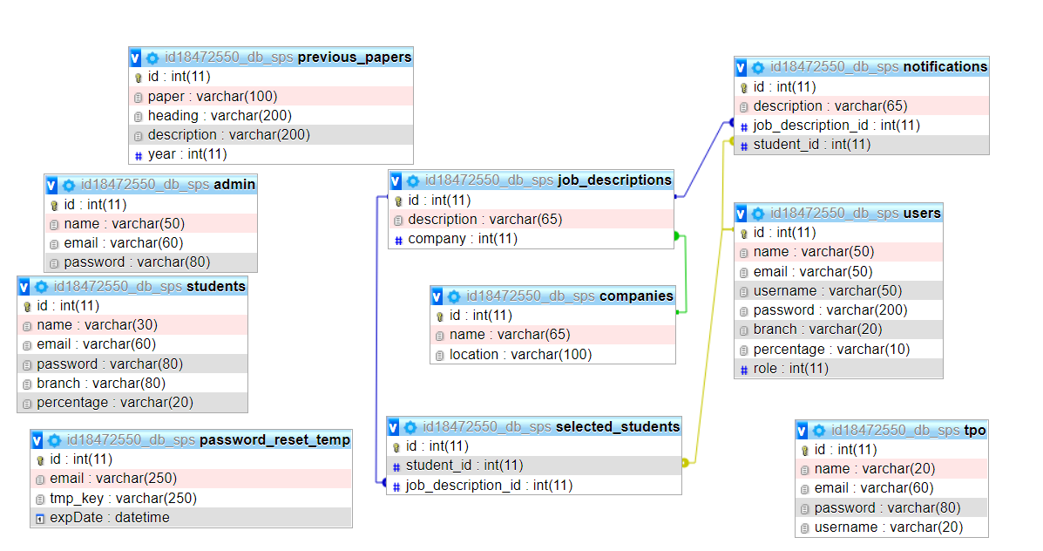

**Screen Shots**

**SPLASH SCREEN :**

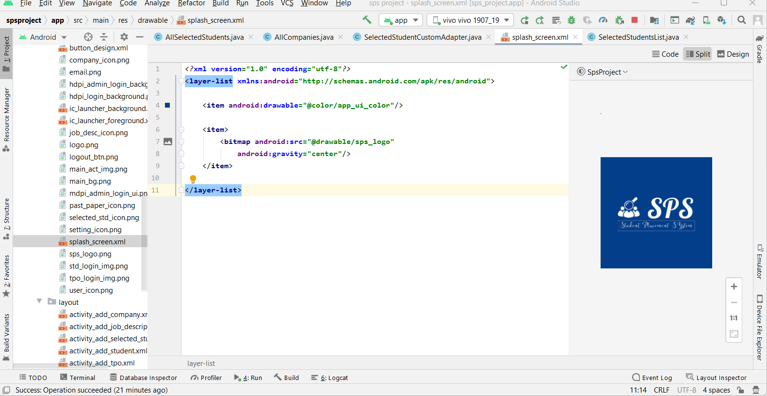

**ALL CATEGORIES LOGIN:**

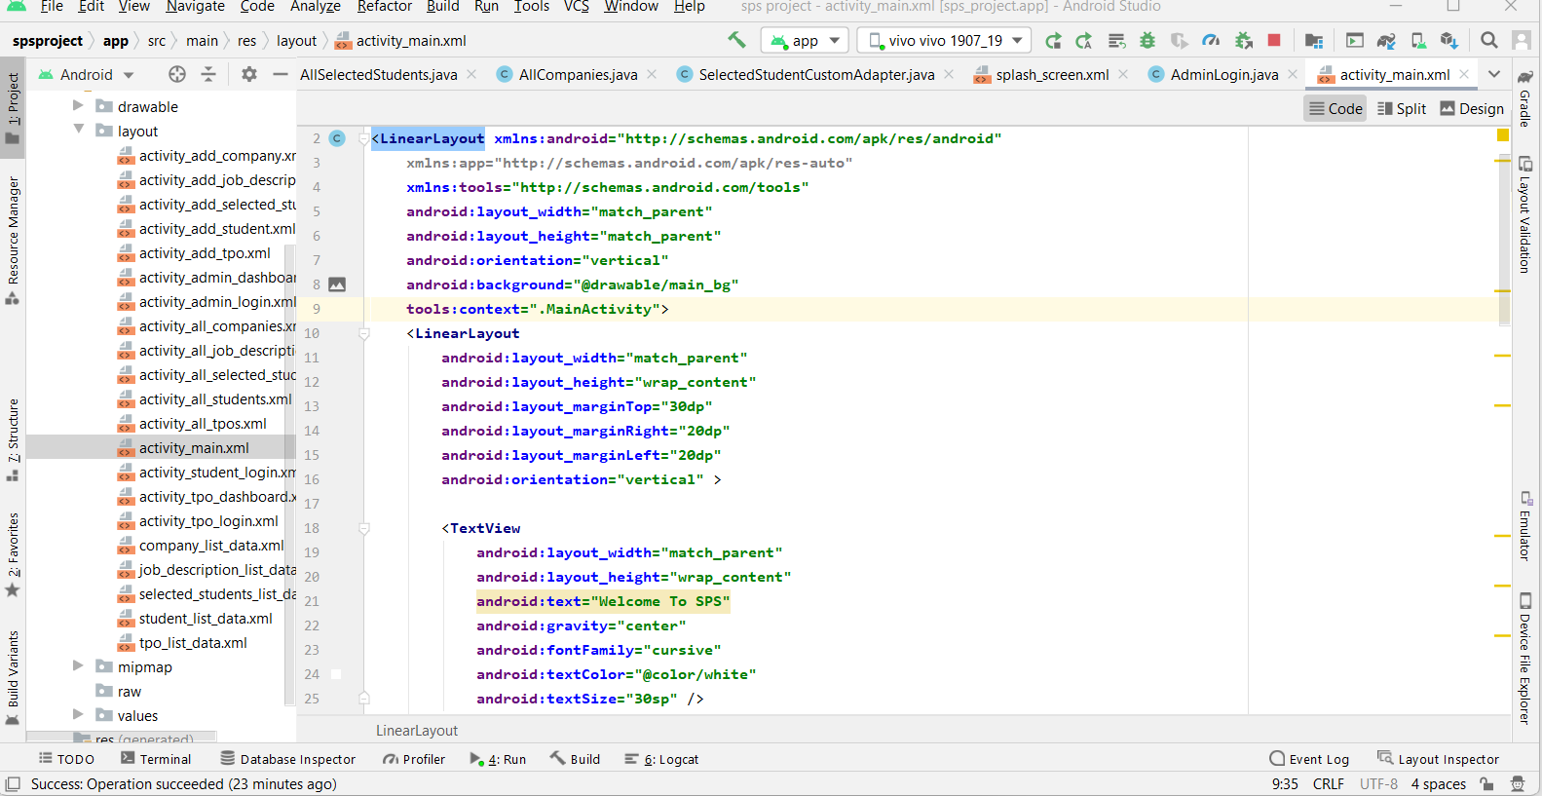

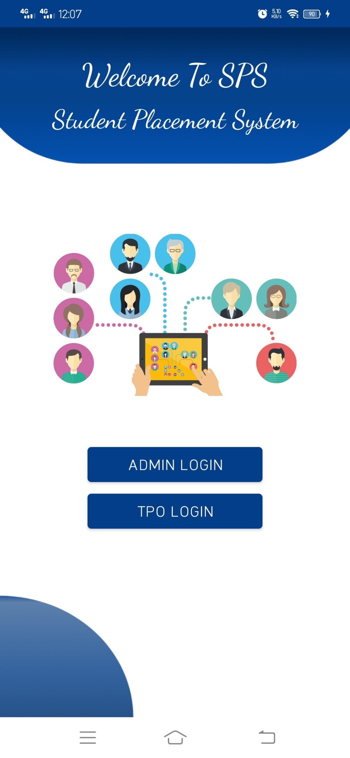

**ADMIN LOGIN:**



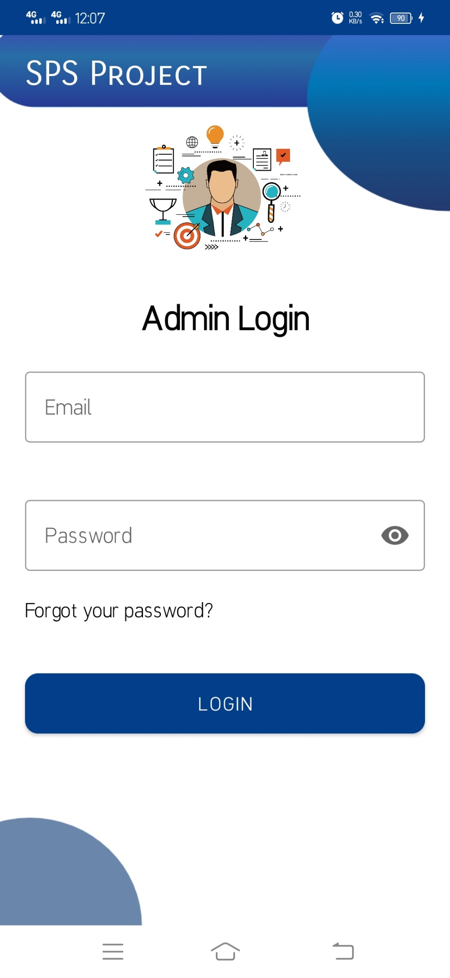

**TPO LOGIN:**

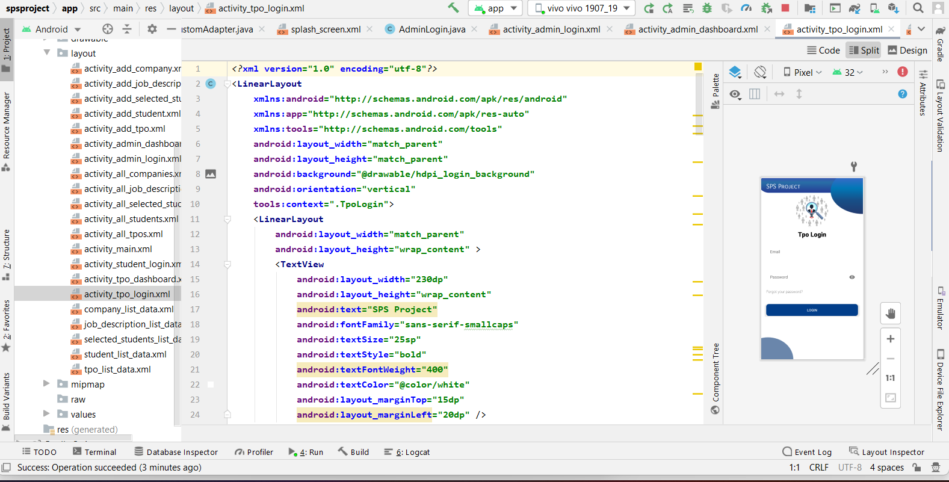

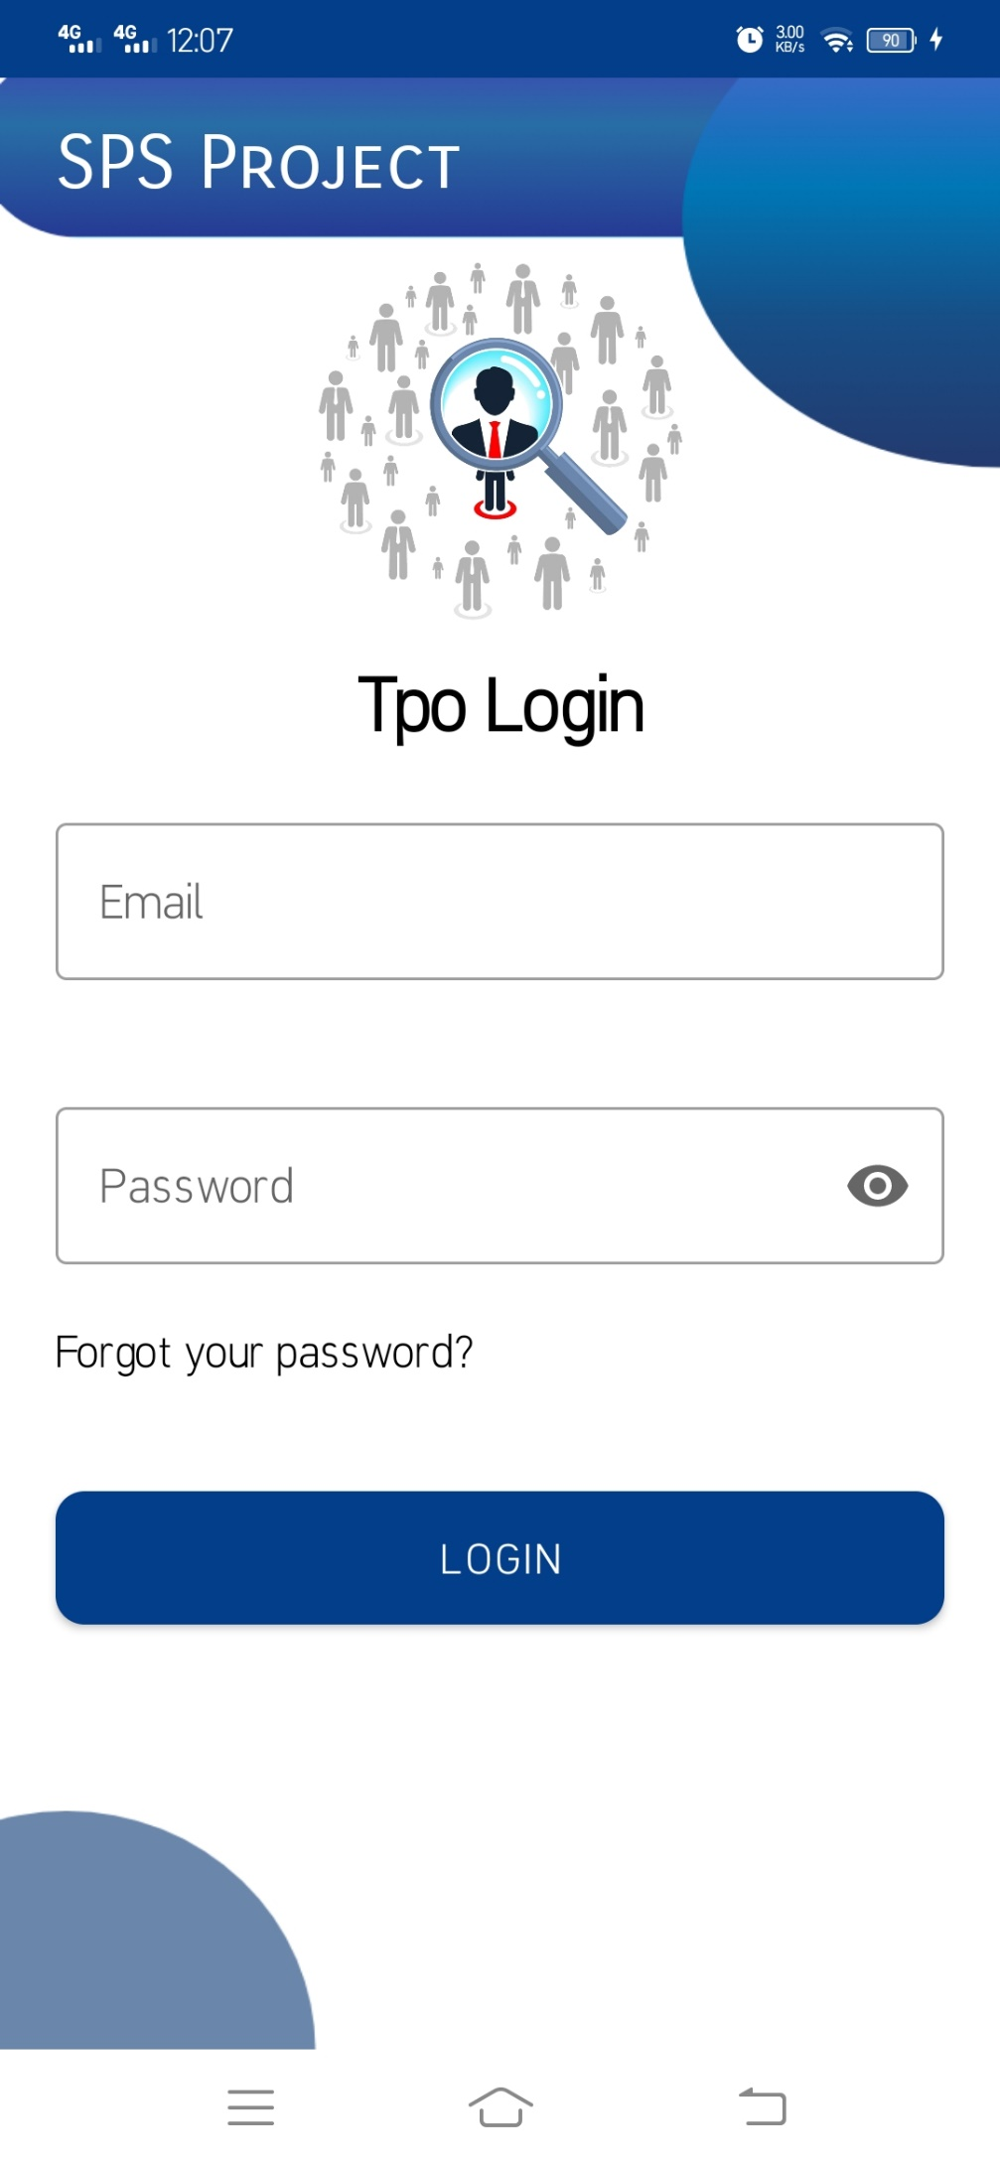

**Remarks:**

It is a very nice initiative that has made us work harder on our project and it has polished our skills and now we are capable of making Android Programing all by ourselves. We are very thankful to you for giving us an incredible opportunity.

**Application:**

It’s an application based on a dynamic application. It provides ease for employees to work faster for testing products. It helps the admin to maintain proper records.

**Future Enhancement:**

It is almost a perfect prototype of **“Student Placement System”** this application can be deployed and used in the real world! But there is always a place for betterment so there are few suggestions, we can also use Retrofit so connection can be made one time and all login areas utilize it.

**Thank You!**